Student Management System

Revision History
Version No. | Date | Prepared by / Modified by | Significant Changes
1. | 29/05/22 | Team 6(GIC 8)

Glossary
Abbreviation | Description
BSC | Business Story Card
TSC | Technical Story Card

Table of Contents
1 Introduction 3
2 Scope of Change 3
3 List of impacted modules 3
4 Design and Detailed technical updates 4
4.1 Process model 4
4.1.1 Use case Model 4
4.1.2 Sequence diagram 4
4.2 Proposed user Interface design 4
4.3 Database design changes 4
4.4 Refactoring related changes 4
4.5 Construction strategy and re-use 4
5 Details of Alternative Design Approach 4
6 Other Technical changes 5
6.1 Automation tasks / changes 5
6.2 CI / Build relates tasks / changes 5
6.3 Non-functional related changes 5
7 Additional details 5
7.1 Open Questions / clarifications / Assumptions 5
7.2 Additional notes to technical team 5
8 References 5

Introduction
This project “Student Management System” provides us a simple interface for maintenance of student information. It can be used by educational institutes or colleges to maintain the records of students easily. Achieving this objective is difficult using a manual system as the information is scattered, can be redundant and collecting relevant information may be very time consuming. All these problems are solved using this project. Throughout the project the focus has been on presenting information in an easy and intelligible manner. The project is very useful for those who want to know about Student Information Management Systems and want to develop software’s/websites based on the same concept. The project provides facilities like online registration and profile creation of students thus reducing paperwork and automating the record generation process in an educational institution.

In our project we can insert Student data and after that data will be inserted. After that we can view data, update data and as well as delete student data.

Scope of Change
The Student Management System(SMS) can be enhanced to include some other functionality like marks, attendance management.
Talent management of students based on their performance evaluation can be added.
Social networking can also be added wherein students can interact with each other.
Online class functionality can be added.
Can evolve as an online institution.
Functionality of chat and messages can be added.
Online exam functionality can be added.
Online resume builder functionality can also be added.

List of impacted modules
In this project there are using basically two modules-

- Insert Student data
- Student data
- Update data
- View data
- Delete data

Design and Detailed technical updates
<Provide details of the Design/approach for developing/implementing the requirements>

Process model

Use case Model
< Provide simple use case model diagram with detailed interaction between various users / systems of the application, refer the story card requirements here>

Student insert
data

Data inserted

Student insert Data

Update data

View data

Delete data

Student see data

Sequence diagram
<Update the sequence diagram on how processes operate with one another and in what order and intent of changes / requirements proposed in the story >

Create student
Update
View
Delete
Database

Data flow diagram

Create Student List
Student list (update, view, delete)
Database

0 Level dfd

Update

Create Student List
Student List
View
Student

Delete

1 level DFD

E R diagram

Stu_firstName
Stu_lastName
Create Student List
Stu Int
Student List
Stu_emailId
Update
Delete
View

Proposed user Interface design
<Document the various interfaces available to the user through this story and module>

Brief Description | Create Student List
Basic Flow | This use case describes how Student gets into User Profile page  - The Student has to create himself into the system.  - The following information is required to Registration.  - First Name  - Last Name  - Email Id
Alternate Flow | Not Applicable
Validation | Not Applicable
Pre-Conditions | User should have network access and Browser with latest updates.
Post-Conditions | Landing page has to be displayed.
Create Student List

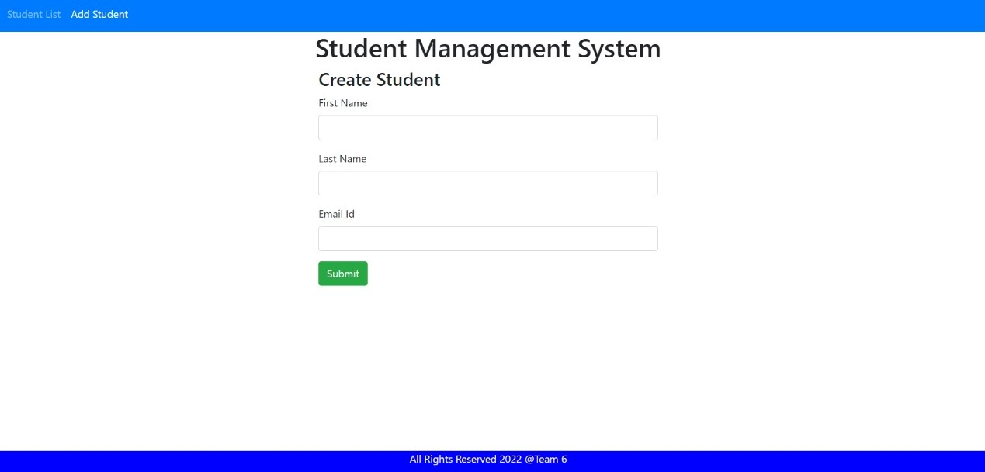

Brief Description | Student List(Update,View,Delete)
Basic Flow | This use case describes how Student can modify their details  - After process the student can be update their profile.  - Update first name  - Last name  - Email id
Alternate Flow | Not Applicable
Validation | Not Applicable
Pre-Conditions | User should have network access and Browser with latest updates.
Post-Conditions | Landing page has to be displayed.

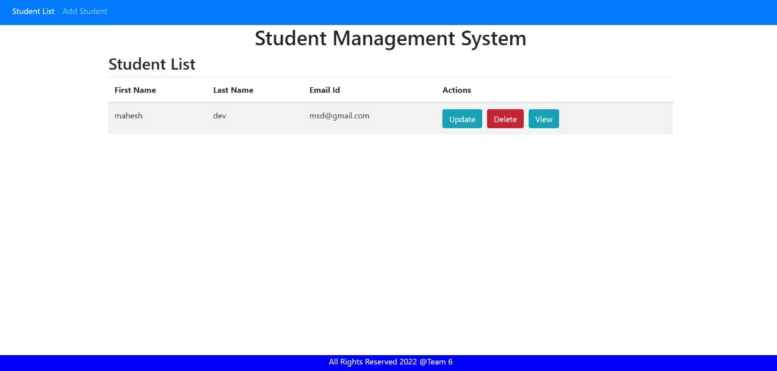

Brief Description | Student List(View)
Basic Flow | This use case describes how Student can view their details  - After process the student can be view their profile.  - first name  - Last name  - Email id
Alternate Flow | Not Applicable
Validation | Not Applicable
Pre-Conditions | User should have network access and Browser with latest updates.
Post-Conditions | Landing page has to be displayed.

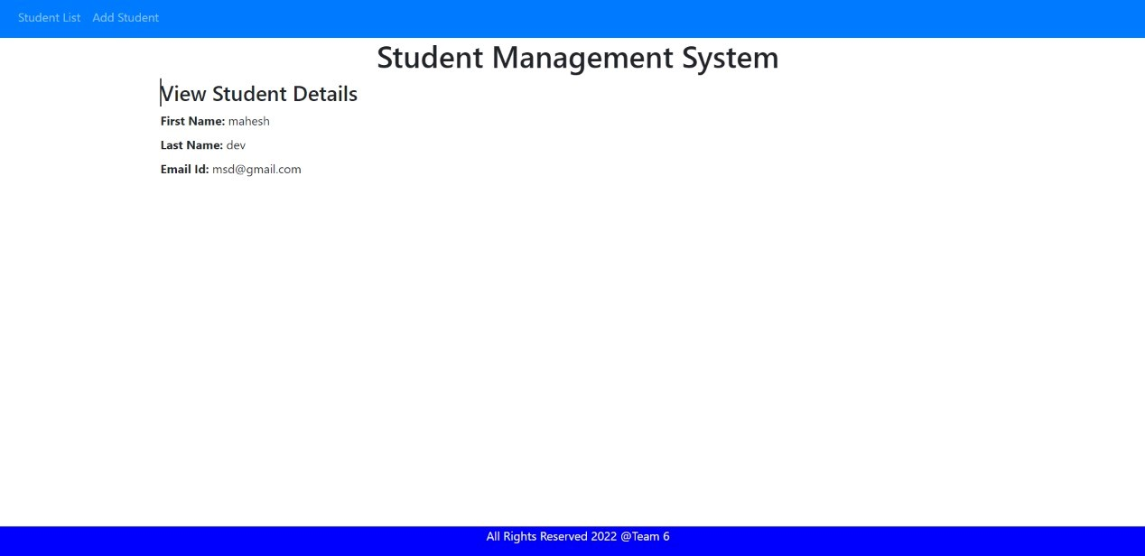

Brief Description | Student list(Delete)
Basic Flow | This use case describes how Student can delete their details  - After process the student can be delete their profile.  - first name  - Last name  - Email id
Alternate Flow | Not Applicable
Validation | Not Applicable
Pre-Conditions | User should have network access and Browser with latest updates.
Post-Conditions | Landing page has to be displayed.

Database design changes
<Provide the logical design of the base data structures used to store the data. E.g. Like tables, and views or entities and relationships>

Create Student List

Add student Data(view)

Stu_firstName
Stu_lastName
Stu_emailId
fName: ABC Update
lName: Xyz View
EmailId: 123@a.com Delete

Delete
Update

fName: ABC
lName:
EmailId: 123@a.com Delete

fName: ABC
lName: XYZ Update
EmailId: 3423@a.com

Architecture

Layer
Logical View
Technology/ Framework

UI Components
Presentation Layer
HTML/ CSS/ JavaScript/ AJAX/ Angular
Export (pdf)
Validations
Resources

Report

Web-Server Classes
Java 1.8/ Spring MVC
Application/ Business Layer
Configuration
Controllers

Service
REST Controllers

Entity/ Model Classes

Data Access Layer
Repository classes
Hibernate ORM

Oracle 11g Database

Presentation Layer:

This layer consists of all UI components.
- Export component: The plug-in is used to export the reports in pdf format. It helps to reduce the workload on the web/ application server.
- Validation component: All basic level data validations should be done at UI level.
- Report component: All reports to be generated to the user, will be processed and generated at the browser end.
- Resources: All HTML/CSS/ images, which are required for the page design.

Application Layer:

This layer comprises of all server and business classes.
- Configuration settings (XML or Class based) will define the application and server configuration.
- Spring Controllers defines the server classes, which are required to process the incoming http requests.
- Service classes are required to perform the required business services.
- REST Controllers to process the HTTP AJAX requests.
- Model classes are used the define the functions of the entities present in the system.

Data Layer:

Data layer is implemented through Hibernate ORM. It will contain the repository classes, which provides interface to the table.

Details of Alternative Design Approach
<Details of the alternative approach to resolve the maintenance request>

Other Technical changes

Automation tasks
<if the story is about automation (of test cases or some POC etc.), mention the details here>

CI / Build relates tasks
<If the story requirements are about implementation of continuous integration or build, update the details to be done here>

Non-functional related changes
<Non-functional requirements related to response time, System load or Network load>

Additional details

Open Questions / clarifications / Assumptions
<Mention the details of any open technical questions/clarifications or assumptions made, pertaining to story >

Additional notes to technical team
<provide details if any>

References
https://www.w3schools.com/
https://www.javatpoint.com/

